**DM Assist**

This tool allows admins to compare fields, check if the field is required in target org (validation, layout and object level) and picklist values between orgs and get a pdf document of the same. The tool allows for users to select the object and get the field and picklist details from that object’s parent and optionally child objects.

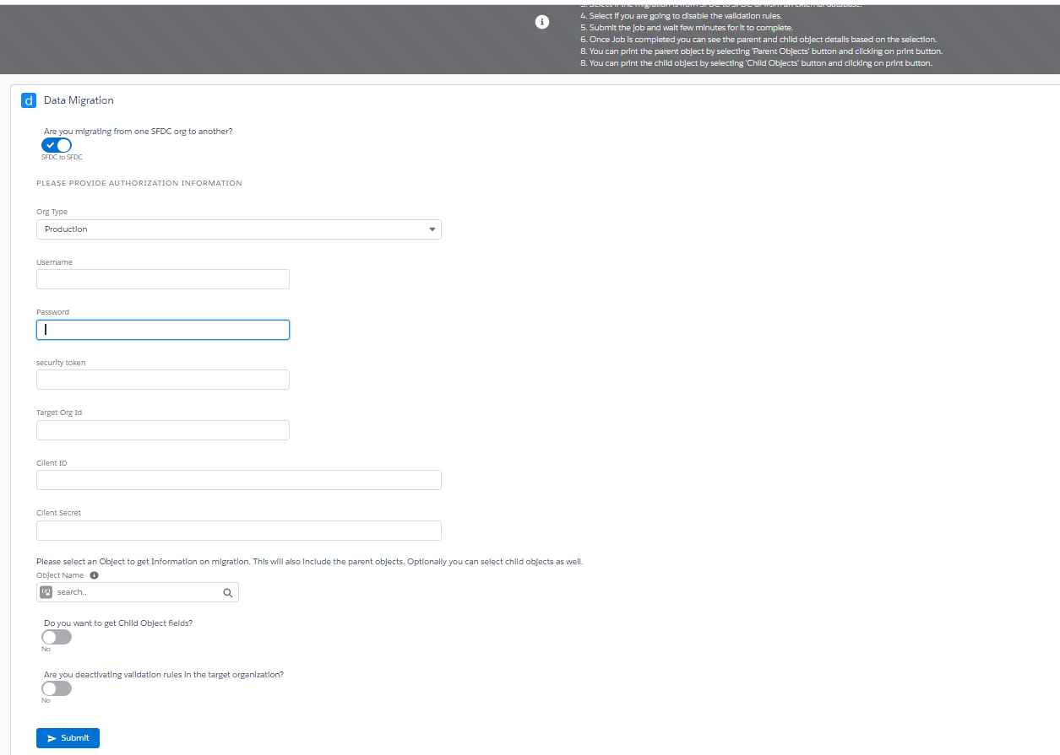

1. Select if the migration is from SFDC to SFDC or from an external database.
2. When user selects external database, only the current org object details are obtained.
3. If SFDC to SFDC is selected, user should select if the target org is production or sandbox.
4. Provide the user credentials, client Id, client Secret, target org Id, security token to perform the authentication. (For this a connected app needs to be created in the target org which we will get back in post Installation activities)
5. Select if child object details need to be retrieved.
6. Select if you are going to disable the validation rules.
7. Submit the job and wait few minutes for it to complete.
8. Once Job is completed the requestor will receive an email. You can see the parent and child object details including picklist values comparison based on the selected object.
9. User can print the parent object by selecting 'Parent Objects' button and clicking on print button.
10. User can print the child object by selecting 'Child Objects' button and clicking on print button.
11. User can print the picklist values comparison from the related parent and child objects and print them.

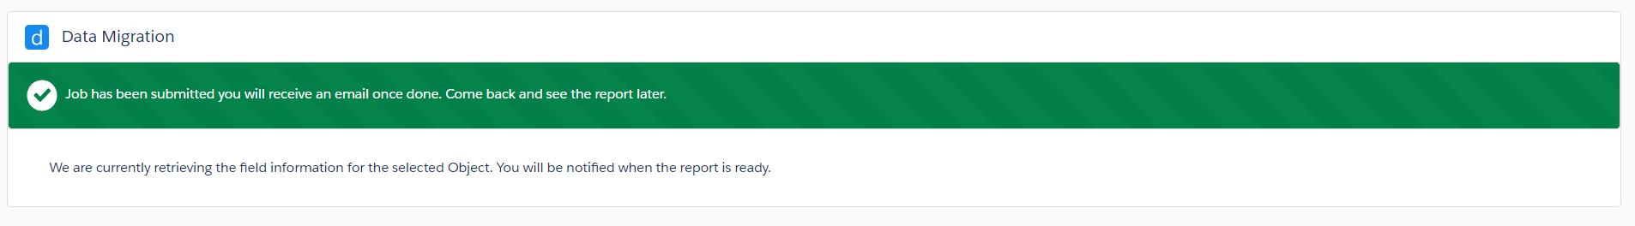

Once submitted, a job is run in salesforce that will connect to the target org and get the object details

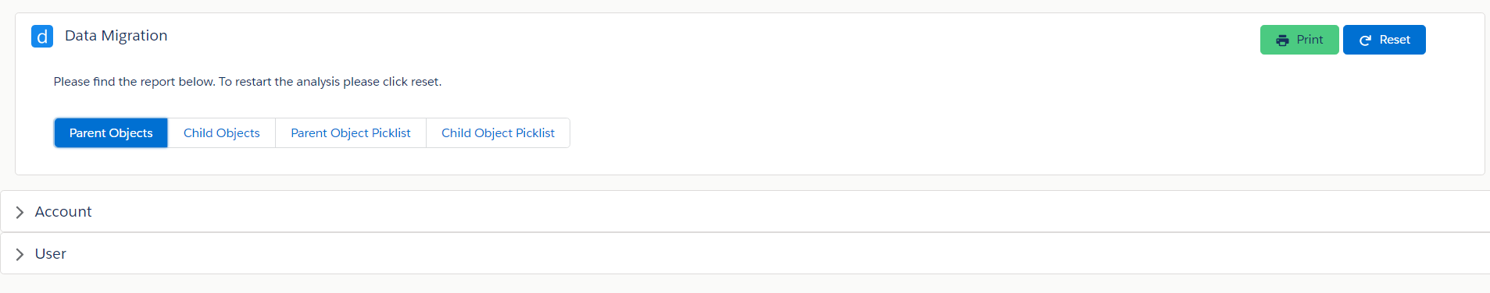

Select any button to get the parent object, child object field or picklist values comparison.

Parent/ Child objects button is selected:

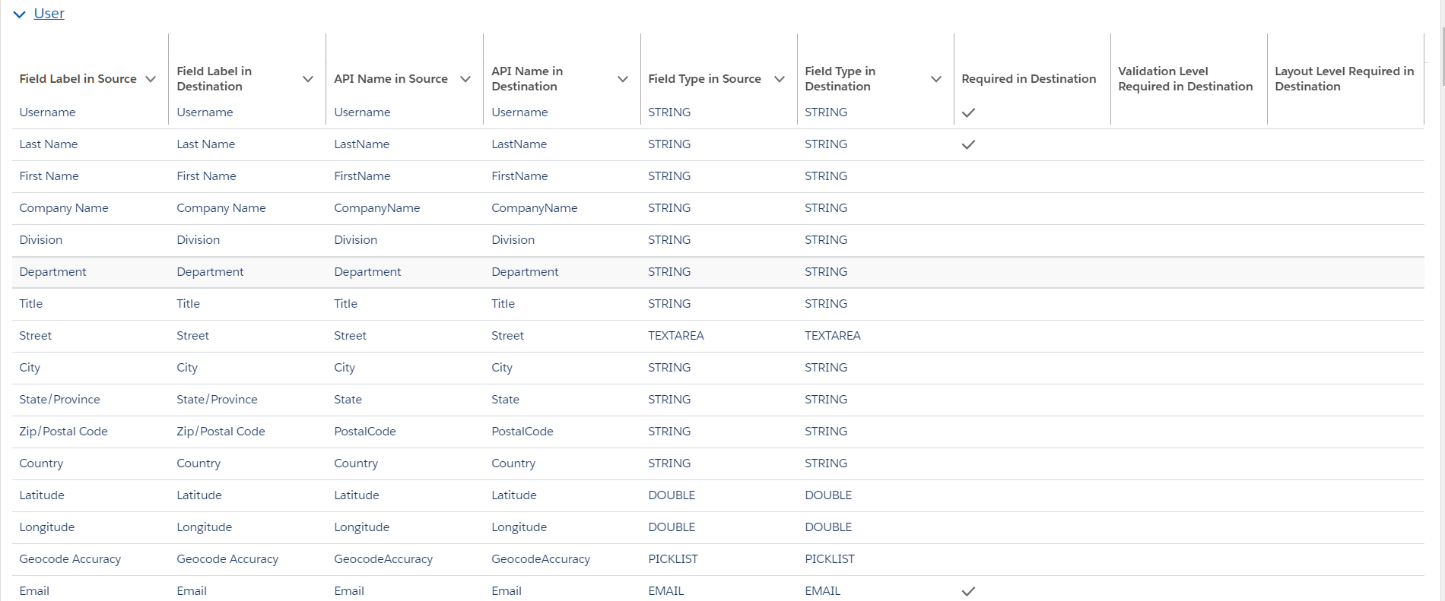

Parent/ Child picklist button is selected:

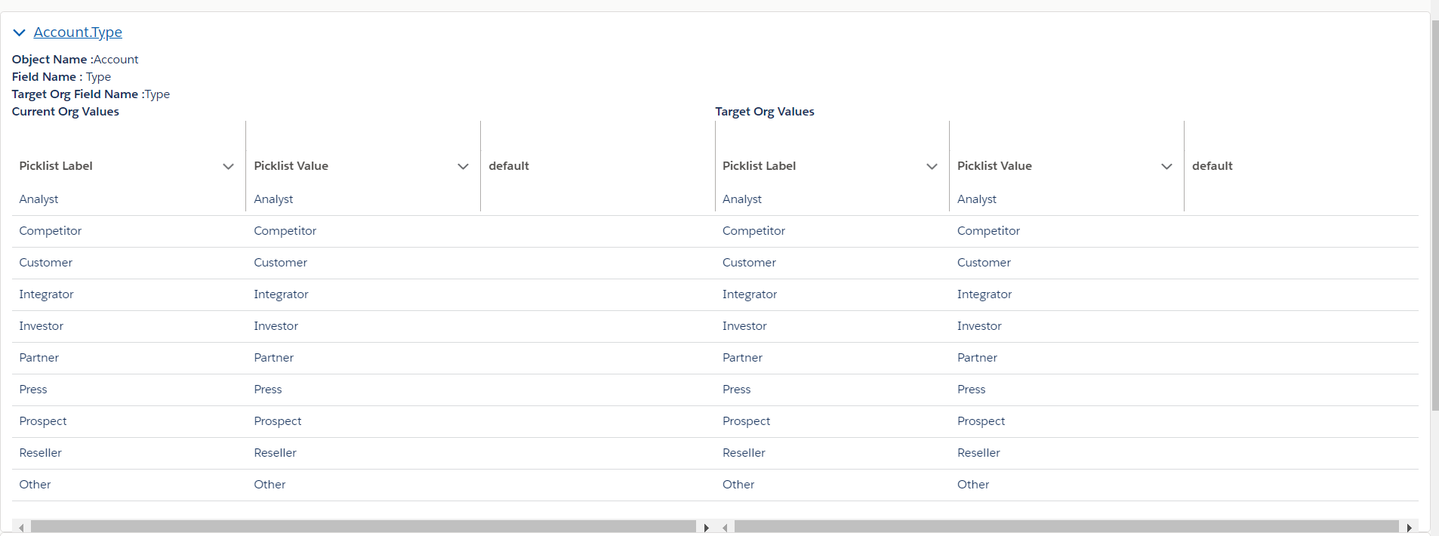

Print and reset buttons are relative to the page and will stay in place at top right, when users scroll down/ up.

Print button will print the page by opening all the accordions displaying the tables and can be saved as PDF.

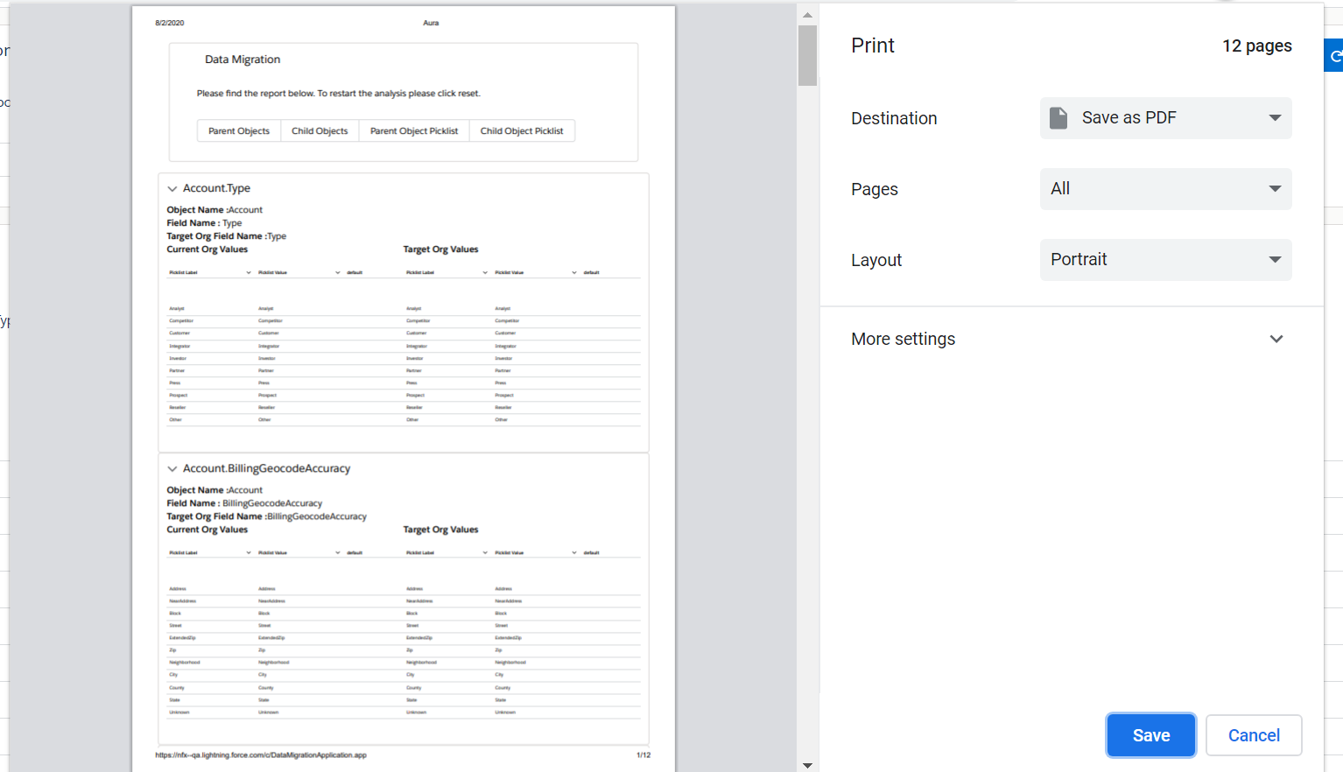

Reset button will reset the object and picklist details to allow users to compare different object.



**DM Assist Post Installation Steps:**

**Source Org:**

Create a custom setting record in Data_migration_auth with below details:

Name- currentIndexMigration

indexNumber- 1

Record Id - use the record Id of the same record after saving.

**Target Org:**

1. Create a connected app in the org with oauth enabled and below settings. Callback url can be the source org and select all oauth scopes.

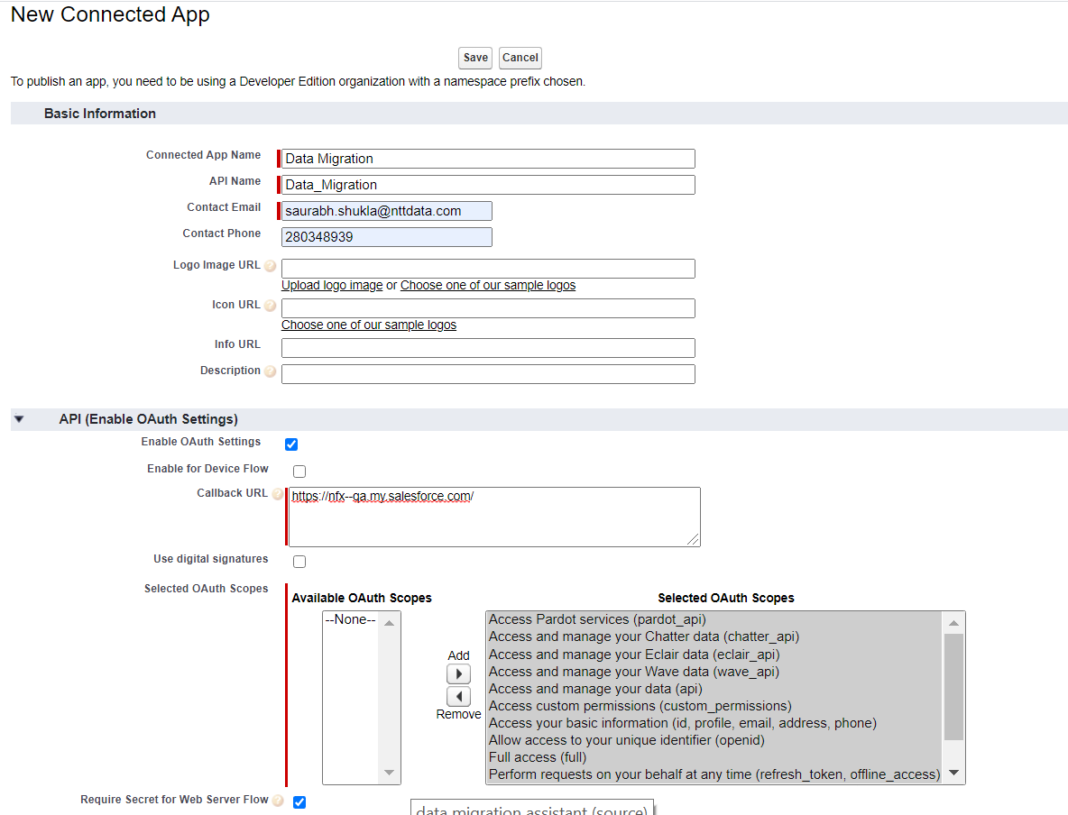

1. Remove all IP restrictions from the org atleast for the user that is making the API connection.
2. Reset the security token.

The client Id, username, password, org id, client secret, security token from this org will be used for connecting to this org from DM Assist application.